


08
Fall
Client Care Desktop
4.50 Editable Value Lists

Contents
Introduction 3
Editable Value Lists 5
Clients 5
Corporate Clients and Schemes 12
Holdings 14
Enquiries 20
Work / Tasks 21
Fact find 22
Compliance 24
Contacts 30
Setup 31

Introduction
An ‘Editable Value List’ is a dropdown list where you can add your own values to make them more relevant for your company.

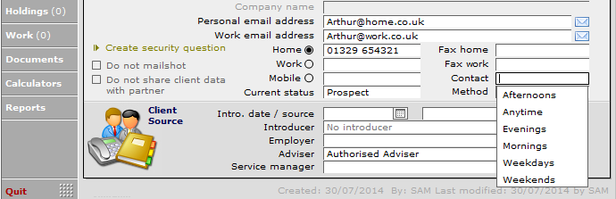

If you have entered additional values to those displayed, when you upgrade to the next version of Client Care Desktop your editable lists will be automatically populated with the core lists and the values you have created.

Each field that is editable will display the message ‘Ctrl click to edit list’ when you rollover the field.

To amend an Editable Value List, navigate to the field, hold down the Control button (Ctrl) and click into the field.

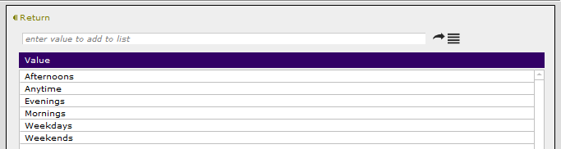

The value list for the field will be displayed, with an option to add a new value to the list by clicking on the button at the top right.

To reset the values in the list, click on the button at the top right to see the following message.

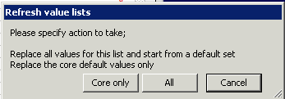

To keep your own additional values and include all of the core system values (included in this document), click on ‘Core only’. This will update the list you are viewing to include all of the latest core system values in addition to your own values.

To reset the values in this list to only display the core system values included in this document, click on ‘All’. This will update the list you are viewing to include all of the latest core system values.

To return to the screen, click on the Return button at the top left.

The lists will be displayed in alphabetical order on the input screen, which will be filtered down as you start to enter data and will auto populate if there is only one option left.

The ability to update these value lists can be provided to all staff or restricted to those who have access to the Setup area of the system.

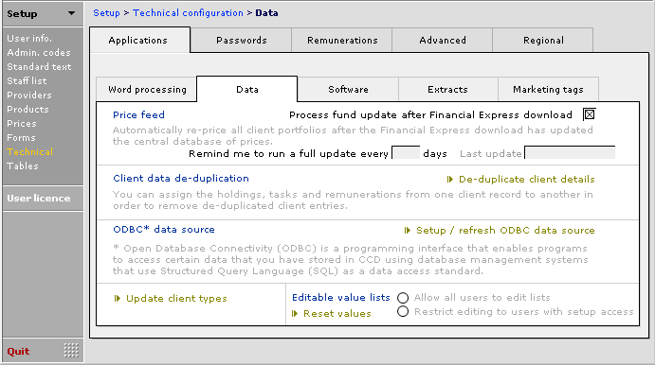

To reset the values in all lists to only display the core system values included in this document, click on ‘Reset values’.

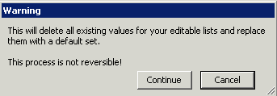

This will remove any values you have added manually across the whole system. Please note that if you set the values back to the core list, any additional values you wish to use will need to be added in manually to each individual list. This action cannot be reversed.

This document details one instance of each of the editable fields. The navigation path to get to any particular field shows just one route to get to it, when in reality there may be a number of areas in the system that will utilize the same value list.

Editable value lists introduced in this release are highlighted in the tables below.

Editable Value Lists

Clients
Path | Editable Field Name (on screen) | Please add your additional fields to the existing editable list
Clients | Contact | Mornings  Afternoons  Evenings  Weekends  Weekdays  Anytime
Clients | Intro. Source | Business development  Client made contact  Client referral  Cold calling  Consultant self-generated  Corporate client employee  Existing client  Mailshot  Marketing list  Other  Referral from Family  Referral from Friend  Referral from intermediary  Referral from Introducer  Referral from Non-authorised introducer  Website
Clients | Method | E-mail  Fax  Letter  Telephone
Clients > Account > Fees (within an existing invoice) | Fee type | Advice only fee  Application fee  Consultancy fee  Credit note  Financial Planning  Invoice Details (Non VAT)  Invoice Details (VAT)  Mortgage consultancy fee  Portfolio management regular review fee  Portfolio management set up fee  Wealth management initial service fee  Wealth management regular service fee
Clients > Account > Fees > Ancillary > (within an existing invoice) | Fee type | Administration fee  Conveyancing fee  Introduction fee  Portfolio management service fee  Wealth management service fee  Will writing fee
Clients > Account > Fees > Fee set-up | Description of the fee | Account management charge  Client Fee Excl VAT  Client Fee Inc VAT  Corporate – Clinics  Corporate - Death In Service  Corporate - Employee Benefits  Corporate - General Consultancy  Corporate - Group Personal Pension  Corporate - Income Protection  Corporate - One to One Advice  Corporate - Other  Corporate - Other Seminars  Corporate - Pre Retirement Courses  Corporate - Retirement seminar  Credit note  Financial Planning  Individual - Annuities  Individual - Bond  Individual - DM Charge  Individual - General Consultancy  Individual - ISAs  Individual - Monthly Account  Individual - Mortgages  Individual - Other  Individual - Personal Pension  Individual - Portfolio management  Individual - Procurement  Individual - SIPPS  Individual - SSAS  Individual - Valuations  Individual - Wealth/lifestyle planning initial  Individual - Wealth/lifestyle planning regular  Legacy Fee Charge  Management Charge  Monthly service fee  Portfolio management standing charge
Clients > Calculators > Retirement > Annuity purchase | Age for calculation | 50  55  60  65  70  75
Clients > Documents (within an existing form) | Category | Adviser assessment  Client assets  Compliance  Development  Money Laundering  Recruitment
Clients > Documents (within an existing form) | Host Product | Email  Microsoft Excel  Microsoft PowerPoint  Microsoft Word  PDF
Clients > Marketing | Source of introduction | Business development  Client made contact  Client referral  Cold calling  Consultant self-generated  Corporate client employee  Existing Client  Mailshot  Marketing list  Other  Referral from Family  Referral from Friend  Referral from intermediary  Referral from Introducer  Referral from Non-authorised introducer  Website
Clients > Marketing > Compliance | Type of SCDD/CIDD (field next to the date) | Combined  Direct offer  Investment and insurance  Lifetime mortgage  Mortgage  Mortgage and insurance  Non menu  Simplified  Standard
Clients > Marketing > Compliance | Type of Menu Date (field next to the date) | Combination  Commission only  Fee only  Fee or commission  Mortgage  Standard
Clients > Marketing > Mailshots (within an existing mailshot) | Initial Action | Annual review  Annual review letter  Change of interest rate notification  Change of premium/contribution notification  Client general enquiry  Client meeting  Cold call to new prospect  Confirmation of appointment  Email prospects  Invitation to seminar  Letter of introduction  Pension Review  Phone Call  Policy maturities  Referral  Scheme membership renewal
Clients > Marketing > Mailshots (within an existing mailshot) | Follow up - contact made | Email sent  Follow Up Call - Left message (at lunch)  Follow Up Call - Left message (in meeting)  Follow Up Letter sent  Follow Up Telephone (No answer)  Implementation  Initial - Fact find  Initial - Pre Fact find  Left message (at lunch)  Left message (in meeting)  Letter sent  Other  Presentation  Telephone call
Clients > Marketing > Meetings (within an existing meeting) | Reason for the meeting | 1st Meeting - Fact find  2nd Meeting - Report Presentation  3rd Meeting – Implementation Review - Update Fact find  Change of circumstances review  Client Request  Pre - Fact find meeting  Review – Fact find  Review – Implementation  Review – Report
Clients > Marketing > Meetings (within an existing meeting) | Meeting venue | Client's business address  Client's home  Office  Social venue
Clients > Marketing > User defined tab | Unspecified 1
Clients > Marketing > User defined tab | Unspecified 2
Clients > Marketing > User defined tab | Unspecified 3
Clients > Marketing > User defined tab | Unspecified 4
Clients > Marketing > User defined tab | Unspecified 5
Clients > Marketing > User defined tab | Unspecified 6
Clients > Marketing > User defined tab | Unspecified 7
Clients > Marketing > User defined tab | Unspecified 8
Clients > Marketing > User defined tab | Unspecified 9
Clients > Marketing > User defined tab | Unspecified 10
Clients > Marketing > User defined tab | Unspecified 11
Clients > Marketing > User defined tab | Unspecified 12
Clients > Personal | State of Health | Excellent  Good  Average  Poor  See notes
Clients > Personal > Employment | Employment Status | Employed  Employed Part-Time  House Husband  Housewife  Long Term Sickness/disability  Not working  Retired  Self employed  Unemployed
Clients > Personal > Employment | Position / title | Administrator  Chief Executive  Consultant  Director  IT Director  Manager  Managing Director  Sales Director  Sales Manager  Technical Director
Clients > Personal > Notes | Security Question | In what city or town was your first job  What is the name of your cat  What is the name of your dog  What is the name of your first child  What is the name of your second child  What is your mother's maiden name  What was the make and model of your first car  What was the name of your first pet  What was the name of your first school  Where were you born
Clients > Postal address | Description | Addressee Unknown  Client's holiday home  Client's home  Client's office  Client's partner's home  Client's power of attorney  Client's Premises  Company Address  Gone Away  Previous Address  Trustee 1 Address  Trustee 2 Address
Clients > Postal address | Private | Addressee only  Confidential  Personal  Private  Private & Confidential
Clients > Reports > General > select report 'Create a report cover sheet for this client' | Report title | Asset Analysis Report  Income & Expenditure Analysis  Life Assurance Requirements  Lifestyle planning report  Personal Financial Review  Portfolio Report  Portfolio Valuation  Retirement Planning Analysis
Clients > Scanned documents (for INVU and Virtual Cabinet users) * | When attaching documents, record it as type | Acceptance Terms  Adviser assessment  Application Form  Benefit Statement  Birth Certificate  Checklist  Cheque  Client assets  Client needs analysis  Client portfolio summary  Client report  Commission Sheet  Compliance  Correspondence with Adviser  Correspondence with Branch  Correspondence with Client  Correspondence with Head Office  Correspondence with Introducer  Correspondence with Network  Correspondence with Provider  Correspondence with Regulator  Death Certificate  Declaration  Development  Evidence of Earnings  Fact find  Fact find supplementary data  File note  GPPP Cheque and Schedule  Justification  Key Features Document  Letter from Client  Letter from Provider  Letter of Authority  Letter to Client  Letter to Provider  Marriage Certificate  Money Laundering evidence  Mortgage Offer  Note of conversation  Note of meeting  P60 / Payslip  Passport  Policy Documents  Quotation / Illustration  Reason Why Letter  Recruitment  Terms of Business  Trust Form  Unit Statement

*Important note for users of the Document Management systems INVU or Virtual Cabinet:
You should take a note of the values on the list within the Clients > Scanned document ‘When attaching documents, record it as type’, as only the last value entered against a client will be displayed in this value list. After the upgrade, this full list will need to be populated following the instructions in this document.
As the editable values have to be entered individually, if you have a long list of values in this field, please inform our Customer Service Team when arranging your upgrade so that our support team can import the dropdown list back into your system post upgrade.

Corporate Clients and Schemes
Path | Editable Field Name (on screen) | Please add your additional fields to the existing editable list
Clients > Holdings > Schemes (within an existing scheme) > Administration | Current position  (outstanding action) | Awaiting acknowledgement  Awaiting application  Awaiting completion  Awaiting information from Adviser  Awaiting information from client  Awaiting Money Laundering  Awaiting policy docs  Awaiting start date  Awaiting Trust  Case cancelled  Case completed  Case declined  Case in force  Case NPW  Case NTU  Case postponed  Case proposed  Case submitted
Clients > Holdings > Schemes (within an existing scheme) > Contacts | Function performed | Company Personnel Manager  Company Secretary  Decision Maker  Director  Executive Administrator  External administrator  HR  HR Administrator  HR Director  Managing Director  Operations
Clients > Holdings > Schemes (within an existing Group Income Protection scheme) > Details | Deferment period | Weeks  Months
Clients > Holdings > Schemes > (within an existing Group Private Medical Insurance Scheme) > Membership (within a member record) > Benefit/premium tab | Hospital bands | A  B  C  D  E
Clients > Holdings > Schemes (within an existing SSAS Scheme) > Sch. Assets > Loan backs (within an existing Loan back) | Loan type | Interest only  Repayment  Schedule
Fact find > Fact find (within an existing Core Fact find for Corporate clients) | Legal structure | Limited Company  Limited Liability Partnership  Limited Partnership  Partnership  PLC  Sole Trader
Fact find > Fact find (within an existing Core Fact find for Corporate clients) | Principal activity | Accounting  Engineering  Financial  Insurance  Legal  Medical  Public sector  Retail
Fact find > Fact find (within an existing Core Fact find for Corporate clients) > Contact > Personal Assist. | Position | Director's Assistant  Manager's Assistant  Personal Assistant

Holdings
Path | Editable Field Name (on screen) | Please add your additional fields to the existing editable list
Clients > Holdings > Administration | Current position (outstanding action) | Awaiting acceptance terms  Awaiting acknowledgement  Awaiting application  Awaiting completion  Awaiting health screening  Awaiting information from Adviser  Awaiting information from client  Awaiting information from lender  Awaiting information from provider  Awaiting MCQ  Awaiting MER  Awaiting Money Laundering  Awaiting mortgage completion  Awaiting mortgage offer  Awaiting PMA  Awaiting PMA & MER  Awaiting policy docs  Awaiting start date  Awaiting transfer of funds  Awaiting Trust  Awaiting underwriting decision  Case cancelled  Case completed  Case declined  Case in force  Case NPW  Case NTU  Case postponed  Case proposed  Case submitted
Clients > Holdings > Administration > Case source | Client source | Business development  Client made contact  Client referral  Cold calling  Consultant self-generated  Corporate client employee  Existing client  Mailshot  Marketing list  Other  Referral from member of staff  Referral from family  Referral from friend  Referral from intermediary  Referral from Introducer  Referral from Non-authorised introducer  Website
Clients > Holdings > Administration > Case Source | Business source | Accountant  Advert  Auto enrolment  Client made contact  Client recommendation  Client referral  Client relative  Cold calling  Consultant self-generated  Direct offer financial promotion  Existing client  Family  Friend  Internet sale  Marketing list  Member of client scheme  Other  Postal sale  Referral from member of staff  Referral from intermediary  Referral from Introducer  Referral from Non-authorised introducer  Repeat customer  Sales visit  Solicitor  Telephone sale
Clients > Holdings > Administration > Case Source | Your contract servicing rights | Company sold the policy  Letter of Appointment  Letter of Authority  Agency takeover
Clients > Holdings > Details > View Trustees | Type of trust | Absolute  Accumulation & Maintenance  Asset protection trusts  Bare  Charitable trusts  Discounted gift trust  Discretionary  Fixed trusts  Hybrid trusts  Interest in Possession  Interspousal bypass trust  Living and testimony trusts  Revocable/irrevocable trusts
Clients > Holdings > Details (valuation data field needs to be set to Transaction) > Assets (within an asset) > Transactions | Transaction type / sub type | AMC  Cancellation  Corporate Event Stock -  Corporate Event Stock +  Purchase  Reinvestment Units  Re-registration  Sale  Security Transfer In  Security Transfer Out  Switch Purchase  Switch Sale  Transfer In (In Specie/Stock)  Transfer In Cash
Clients > Holdings (Bank/Building Society Account) > Details | Interest Type | Fixed  Guaranteed  Index linked  Tracker  Variable
Clients > Holdings (Bank/Building Society Account) > Details | Withdrawal notice period (if any) | 1  7  30  60  90  180
Clients > Holdings (Income Protection) > Details | Definition of occupation | Activities of daily work  Any occupation  Own occupation
Clients > Holdings (Loan) > Details | Purpose of the loan | Car purchase  Debt consolidation  Holidays
Clients > Holdings (Mortgage) > Details | Mortgage Basis | Capital Raising  Debt consolidation  Equity release  First time buyer  Investor  Other  Owner occupier  Right to buy  Second home  Sub-prime
Clients > Holdings (Mortgage) > Details | Repayment Vehicle | Capital repayment  Existing Endowment  Existing Endowment, part Interest Only  ISA  None  Other  Part Capital repayment, part Interest Only  Pension  PEP
Clients > Holdings (Mortgage) > Details | Special requirements | 100% plus lending  Adverse credit  Cash-Back  Discharged Bankrupt  Guarantor  None  Past retirement  UK Expatriate
Clients > Holdings (Pension) > Details | Return on Death Before Retirement | No return  Return of contributions  Return of fund  Return with interest
Clients > Holdings (Private Medical Insurance) > Details | Cover provided | Family  Married  Personal  Single  Single Parent Family
Clients > Holdings (plans that have income tab i.e. Income Drawdown) > Details > Income > Income Summary (within an existing income record) | Reason for the drawdown | Income  Tax free cash entitlement & Income  Top-up income
Clients > Holdings > Details > Withdrawals > Withdrawal (within an existing withdrawal record) | Reason for the withdrawal | Contract surrender value  Distribution Payment  Dividend income  Encashment  Full Surrender  Lump sum withdrawal  Partial Encashment  Partial Surrender  Provide tax efficient income  Re-alignment of risk profile  Regular income  Switch funds into an ISA  Transfer to SIPP
Clients > Holdings > Product | Contract reason/objective | Business Assurance  Corporate Business  Debt consolidation  Further mortgage advance  General Review  Group Pension Income Expectation  Increase in capital assets  Increase in net income  Investment of lump sum  Keyman Assurance  Minimising inheritance tax  Product review  Protection against medical expenses  Protection of home  Protection of Income  Protection of mortgage  Providing security for family  Provision for retirement  Provision for school fees  Purchase of business premises  Purchase of home  Purchase of investment property  Raising additional finance  Relocation of business  Remortgage  Repayment of loans / mortgage  Saving excess income  Seminar / Clinic
Clients > Holdings > Product | Reason (for Next contract review date) | 5 Yearly Review  Annual review  Drawdown Review  Financial Planning Review  General Review  Interim review  Policy Option  Rate Review  See Notes  Triennial review
Clients > Holdings (Mortgage) > Repayments | Rate Type | Cap and Collar  Capped  Discounted  Fixed  Flexible  Lifetime  Offset  Other  Standard Variable  Tracker
Clients > Holdings (Loan) > Repayments | Rate type | Discounted  Fixed  Variable
Clients > Holdings > Submission (field next to SCDD/CIDD Date Sent) | SCDD/CIDD version | Combined  Direct offer  Investment and insurance  Lifetime mortgage  Mortgage  Mortgage and insurance  Non menu  Simplified  Standard
Clients > Holdings > Submission (field next to Menu date sent) | Menu version | Combination  Commission only  Fee only  Fee or commission  Mortgage  Standard
Clients > Holdings > Submission | Replacement Policy | Better charging structure  Better premium  Better range of funds  Change in circumstances  Change of risk profile  Concerns over existing provider  Consolidation of investments  Loan Trust  Move out of closed fund  Move pension to SIPP  Move pension to SSAS  Need to generate income  Pension Transfer  Remortgage for better rate  Remortgage for capital raising  Remortgage for debt consolidation  Tax efficiency
Clients > Holdings > Submission > Replacement policy (click on Details button) | Source of the funds / contract replaced | Occupational scheme transfer value  Personal investment surrender value  Unknown

The editable fields that are found in the holdings screens are not necessarily displayed on all holdings types.

Enquiries
Path | Editable Field Name (on screen) | Please add your additional fields to the existing editable list
Clients > Holdings > Enquiries > (within an existing enquiry) | Current position | Advice accepted, applications returned  Advice accepted, awaiting application  Advice given, application awaited  Advice given, awaiting response  Advice given, keep current holding  Advice given, meeting required  Appointment arranged  Awaiting information  Awaiting: adviser response  Awaiting: client response  Awaiting: Money laundering documents  Enquiry acknowledged but not actioned  Enquiry received but not acknowledged  Fact find completed, awaiting analysis  Fact find completed, awaiting report  Fact find issued for client completion  Fact find issued for client completion  Fact find meeting arranged  Fact find required, meeting to be arranged  Follow Up meeting arranged  Lead allocated  Needs analysis currently being undertaken  Needs identified, awaiting holistic report  Needs identified, awaiting Suitability Letter  Needs identified, holistic report issued  No further action required  Quote issued, awaiting response  Report issued, recommendations logged  Seminar/Clinic Income

Work / Tasks
Path | Editable Field Name (on screen) | Please add your additional fields to the existing editable list
Clients > Work (within an existing work record) | Further action required | Blank to add a list of further actions to be selected across the system or can be typed into if entering specific action on that work record
Clients > Work (within an existing work record) | Priority | 1, 2, 3, 4, 5
Clients > Work (within an existing work record) > Account | Activity | Administration  Analysing needs  Business management  Client facing  Compliance  Fact finding  Personal development  Report writing  Travelling
Clients > Work (within an existing work record) > Message | Private | Addressee Only  Confidential  Personal  Private  Private & Confidential
Clients > Work (within an existing work record) > Message > Set Type of correspondence to Memo > Generate Correspondence | Blank fields below ‘Evidence of earnings’ | Acceptance Letter  Additional Information Form  Cheque for first premium £  Cheque for single premium £  Client identity form  Commencement of risk - immediate  Commencement of risk on  Commencement of risk TBA  Contract Note  Copy correspondence  Declaration of Health  Deed of Appointment  Execution Only Letter  Health Questionnaire  Introducer Agreement  Letter Of Authority  Marriage Certificate  Other Compliance Requirements  Policy Documents  Reason Why letter  See comments below  Supplementary Questionnaire  Transaction Advice  Trust Form  Urgent Acceptance Required

Fact find
Path | Editable Field Name (on screen) | Please add your additional fields to the existing editable list
Fact find > Personal details | Smoker detail | Chewing tobacco  Cigarettes – Unknown  Cigarettes < 05 per day  Cigarettes < 10 per day  Cigarettes < 15 per day  Cigarettes > 05 per day  Cigarettes > 10 per day  Cigarettes > 15 per day  Cigars  None  Pipe  Snuff
Fact find > Fact find > Completion | Status of Fact find completion | Issued  Outstanding  Received  Update complete  Update requested
Fact find > Fact find > Marketing | Category of Client | A  B  C  D  E
Fact find > Fact find > Personal > Prof. contacts > Other | Contact Type | Accountant  Banker  Doctor  Estate agent  Financial planner  Investment manager  Lender  Other  Paraplanner  Property developer  Solicitor  Stockbroker  Surveyor
Fact find > Fact find > Personal > Affordability > Income > Tax, National Insurance and other | Highest (marginal) tax rate | 0.00  0.10  0.20  0.22  0.40  0.50
Fact find > Fact find > Personal > Affordability > Income > Tax, National Insurance and other link | Other | Various
Fact find > Fact find > Personal > Borrowing | Tenure of Property | Flying freehold  Freehold  Leasehold  Shared
Fact find > Fact find > Personal > Borrowing | Fail/Pass | Complete  Limited Disclosure  N/A  Not Disclosed
Fact find > Fact find > Personal > Net worth > Assets > Other (Personal effects) | Other | Various
Fact find > Fact find > Planning > Protection | Adviser Comment | Agreed
Fact find > Fact find > Planning > Protection > Critical illness | Adviser Comment | Agreed
Fact find > Fact find > Planning > Protection > Income Protection | Adviser Comment | Agreed
Fact find > Fact find > Planning > Protection > Medical | Adviser Comment | Agreed
Fact find > Fact find > Planning > Investment > Lump sum | Adviser Comment | Agreed
Fact find > Fact find > Planning > Investment > Lump Sum > Analysis | Investment Goal | Capital sum to fund University fees
Fact find > Fact find > Planning > Investment > Regular savings | Adviser Comment | Agreed
Fact find > Fact find > Planning > Investment > Regular Savings > Analysis | Frequency of Saving | Ad-hoc  Annual  Half yearly  Monthly  Other  Quarterly  Weekly
Fact find > Fact find > Planning > Retirement | Adviser Comment | Agreed
Fact find > Fact find > Planning > Long term care | Adviser Comment | Agreed
Fact find > Fact find > Planning > Inheritance > Inheritance Tax | Adviser comment | Agreed

Compliance
Path | Editable Field Name (on screen) | Please add your additional fields to the existing editable list
Compliance > Adviser | Title | Dr  Miss  Mr  Mrs  Ms  Rev  Sir
Compliance > Adviser | Category | Administration  Adviser  Branch Manager  Business Development Director  Business Development Manager  Compliance  Consultant  DMS  Finance  Finance Director  HR  IFA  IT  Managing Director  Marketing  Paraplanner  Pensions Administrator  Sales Director  Sales Manager  Secretarial
Compliance > Adviser | Current Adviser status | CF30 – Investment Adviser  CF30 – Pension Transfer Specialist  CF30 – Discretionary Manager  Mortgage + Protection Only  CF30 + Mortgage & Protection  Mortgage
Compliance > Adviser | Initial Adviser status | Competent  Experienced new entrant  Internal New Consultant  New entrant  Estate planning specialist  Investment specialist  Long term care/equity release specialist  Mortgage specialist  On Maternity Leave  Paraplanner  Pension and Divorce specialist  Pension specialist  Taxation planning specialist  Trainee
Compliance > Adviser | Training program required | Full  Modified  No Longer Required
Compliance > Adviser > Adviser T&C > Development (within an existing Development record) | Development Identified | Financial Planning  Long term care/equity release planning training  Pension transfer planning training  Positioning Fees  Regulatory training  Retirement planning training  Skills training  Studying for Qualifications  Tax planning training  Technical training  Time management  Training on asking for referrals  Training on closing the sale  Training on firm's policy and procedures  Training on FCA regulation  Training on IHT and estate planning  Training on pension arrangements in divorce  Training on regulation  Training on time management  Training on use of firm's technology  Working with fees  Working with Introducers
Compliance > Adviser > Adviser T&C > Development (within an existing Development record) | Method/s of training to be used | External training  Internal training  Professional Course  Shadow Colleague  Specialist Reading
Compliance > Adviser > Adviser T&C > Development (within an existing Development record) | By Who | Adviser  Assessor  Compliance Officer  External trainer  Internal trainer  Self-study  Supervisor  T&C Officer
Compliance > Adviser > Adviser T&C > Development (within an existing Development record) CPD (within an existing CPD record) | CPD Description | Attendance at conferences  Distance learning courses  Exam study  Formal training and learning events  Other agreed CPD activity  Private study  Researching special client needs  Skills development in - house  Specialist reading  Work with professional and trade bodies
Compliance > Adviser > Adviser T&C > Development (within an existing Development record) > Results | Overall Result | Fail  Pass  Review
Compliance > Adviser > Adviser T&C > Observations | Next observation type | Manager one to one  Observed interview  One to One  Role Play  Stage 2 assessment
Compliance > Adviser > Adviser T&C > Qualifications > Other | Examinations | AF1 Personal tax and trust planning  AF2 Business financial planning  AF3 Pension planning  AF4 Investment planning  AF5 Financial planning process  AF6 Senior management and supervision  AFPC  CER  CF1 UK financial services regulation & ethics  CF2 Financial Planning certificate  CF4 Retirement planning  CF5 Integrated financial planning  CF6 Mortgage advice  CF8 Long Term Care  CF9  CFP  CIP  DFP level 4  Environments  ER1 Equity release  FA1 Life office administration  FA2 Pension administration  GR1 Group risk  J07 Supervision in a regulated environment  J09 Paraplanning  J10 Discretionary investment management  J11 Wrap and platform services  JO1Personal Tax  JO2 Trusts  JO3 The tax & legal aspects of business  JO4 Pension funding options  JO5 Pension income options  JO6 Investment principles, markets &  MAQ  R01 Financial services regulation and ethics  R02 investment principles and risk  R03 personal taxation  R04 Pensions and retirement planning  R05 Financial protection  R06 Financial planning certificate  SV1  QCF level 3  QCF level 4  QCF level 5  QCF level 6  QCF level 7  QCF level 8
Compliance > Adviser > Financial > Fee set up (within an existing Fee) | Description of the fee | Lead generation fee  Monthly membership charge  Standing charge for use of office  Standing support / secretarial charge
Compliance > Adviser > Recruitment > Credit checks (within an existing Personal Credit check record) | Agency Used | CCN  Equifax  Experian
Compliance > Adviser > Recruitment > Credit checks (within an existing Personal Credit check record) | Search Result | Bankrupt  CCJ  CCJ  Clear  Default  No trace
Compliance > Adviser > Recruitment > History | Background | Bank Assurance  IFA  Independent  Mortgage  Multi-tie  Not Registered  Restricted  Tied  Tied Agent
Compliance > Adviser > Recruitment > References (within an existing reference) | Title | Dr  Miss  Mr  Mrs  Ms  Rev  Sir
Compliance > File checks > File reviews (within an outstanding file check) > Review results | Issue/s outstanding | Awaiting copy application form  Awaiting copy execution only letter  Awaiting copy Fact find  Awaiting copy file  Awaiting copy insistent client letter  Awaiting copy suitability letter  Awaiting various items  Need to action addendum
Compliance > File checks > File selection (within a manually selected file check) > Reason selected | Reason | Additional file checking  File for core licence sign off  Further investigation  High commission case  High risk clients  High risk product  High sum assured  New Consultant sign off  Random selection  Status of the Adviser
Compliance > KPIs > Outstanding (within an outstanding KPI report) > Sign-off | Overall assessment | Review  Pass  None undertaken  Fail
Compliance > Registers > Complaints (within an existing complaint) | Nature of complaint | Arrears handling  Breach of customer agreement or contract  Delay  Disputes over sums / amounts payable  Failure to carry out instructions  FCA Compliance breach  Misleading advertising  Other  Other administrative errors  Overcharging  Poor customer service  Poor maintained files  Switching / Churning  Unsuitable or misleading advice
Compliance > Registers > Complaints (within an existing complaint) | Complaint delivery | Email  Fax  Letter  Telephone
Compliance > Registers > Fin Proms. (within an existing promotion) | Type of promotion | Display  E-mail broadcast  Mailshot  Newsletter  Presentation  Published Advertisement  Stationery
Compliance > Registers > Fin Proms. (within an existing promotion) | Purpose | Generate e-new business  Generate leads for a sales advisers  Generate leads for a seminar  Promote use of company website  Sell off the page
Compliance > Registers > Fin Proms. (within an existing promotion) | Placement | Flier through door  Local newspaper  Local shop window  National newspaper  Not applicable  Regional newspaper  Website  Yellow pages
Compliance > Registers > Disciplinary (within an existing Discipline record) | Record complete | No - pending completion of diary  No - pending interview with Adviser  Yes
Compliance > Registers > Breaches (within a breach record) | Conducted by | Company breach  Registered Individual
Compliance > Work > Events (within an existing Event record) | Event | Compliance plan  Compliance review  FSA Annual return  FSAVC return  Pensions quarterly return  T&C Review

Contacts
Path | Editable Field Name (on screen) | Please add your additional fields to the existing editable list
Contacts > (within an existing Contact) | Title | Dr  Miss  Mr  Mrs  Ms  Rev  Sir
Contacts > (within an existing Contact) | Contact Type | Accountant  Banker  Doctor  Estate agent  Lender  No Payaway Introducer  Other  Paraplanner  Property developer  Solicitor  Stockbroker  Surveyor

Setup
Path | Editable Field Name (on screen) | Please add your additional fields to the existing editable list
Setup > Products (within an existing product) > Information | Allocation of debt | Bank loans  Building Society loans  Credit cards  Hire purchase  Mortgage (other property)  Mortgage (private residence)  Overdraft  Further advance  Second charge
Setup > Products > Other Assets | Sector | Active Managed  Absolute Return  Aerospace  Airlines & Airports  Asset Managers  Auto Parts  Automobiles  Balanced Managed  Banks  Beverages - Brewers  Beverages - Distillers & Vintners  Broadcasting Contractors  Builders Merchants  Building & Construction Materials  Business Support Services  Cable & Satellite  Cash  Cash Reserve  Cautious Managed  Chemicals - Advanced Materials  Chemicals - Commodity  Chemicals - Specialty  Clothing & Footwear  Commercial Vehicles & Trucks  Computer Hardware  Computer Services  Consumer Finance  Corporate Bond  China  Defence  Discount & Super Stores & Warehouses  Diversified Industrials  Education  Electrical Equipment  Electricity  Electronic Equipment  Engineering - Contractors  Engineering - General  Engineering Fabricators  Environmental Control  Europe Excluding UK  Europe Including UK  European Smaller Cos  Far East Excluding Japan  Far East Inc Japan  Farming & Fishing  Fixed-Line Telecommunications Services  Food & Drug Retailers  Food Processors  Furnishings & Floor Coverings  Gaming  Gas Distribution  GILT  Global Bonds  Global Emerging Markets  Global Growth  Gold Mining  Hospital Management & Long Term Care  Hotels  House Building  Household Appliances & Housewares  Household Products  Insurance Brokers  Insurance - Non-Life  Internet  Investment Banks  Investment Companies  Japan  Japanese Smaller Cos  Latin America  Leisure Equipment  Leisure Facilities  Life Assurance  Media Agencies  Medical Equipment & Supplies  Mining Finance  Money Market  Mortgage Finance  North America  Not yet assigned  Nth American Sm Cos  Oil - Integrated  Oil - Services  Oil & Gas Exploration & Production  Other Construction  Other Financial  Other Health Care  Other Insurance  Other Mineral Extractors & Mines  Other Textiles & Leather Goods  Paper  Personal Pensions  Personal Products  Pharmaceuticals  Property  Property Agencies  Protected/Guaranteed  Publishing & Printing  Rail  Real Estate Holding & Development  Restaurants and Pubs  Retailers - Hardlines  Retailers - Multi Department  Retailers - Soft Goods  Security & Alarm Services  Semiconductors  Shipping & Ports  Soft Drinks  Software  Specialist  Steel  Technology & Telecoms  Telecommunications Equipment  Tobacco  UK All Companies  UK Corporate Bond  UK Equity & Bond Income  UK Equity Income  UK Equity Income & Growth  UK Fixed Interest  UK Gilt  UK Index-Linked Gilts  UK Other Bond  UK Smaller Companies  Unauthorised  Unclassified  Water  Wireless Telecommunication Services
Setup > Products > Other Assets | Asset type | Agricultural property  Cash  Commercial property  Exchange Traded Fund  Gilts  Investment Fund  Investment Property  Loan  Money Market  National Savings  Overseas Securities  Personal assets  Residential property  Structured Investments  Traded endowments  UK Equities  UK Fixed Interest  Venture Capital Trust
Setup > Providers (within an existing provider | Title | Dr  Miss  Mr  Mrs  Ms  Rev  Sir
Setup > Providers (within an existing provider) > More button | Contact for | Administration  Agencies  All  Commissions  Compliance  Marketing  Mortgage admin.  National accounts  New Business  Quotations  Valuations
Setup > Providers (within an existing provider) > More button | Office Name | Head office  Local branch  Regional office
Setup > Providers (within an existing provider) > Information > Services | Groups to which the Provider belongs | Annuity provider  Commercial insurer  Commissions administrator  Discretionary fund manager  Fund supermarket  General insurer  Lender  Life protection and savings  Mortgage packager  Pensions provider  Stock broker  Traded endowments  Trust company
Setup > Staff List | Title | Dr  Miss  Mr  Mrs  Ms  Rev  Sir
Setup > Staff List | Category | Administration  Adviser  Branch Manager  Business Development Director  Business Development Manager  Compliance  Consultant  DMS  Finance  Finance Director  HR  IFA  IT  Managing Director  Marketing  Paraplanner  Pensions Administrator  Sales Director  Sales Manager  Secretarial
Setup > Staff List | Team | Administration  Compliance  Consultant  Finance  Management  Paraplanning
Setup > User information > Banking | Standing order collection day | 1st day of each month  25th day of each month
Setup > User info > Locations > Branches > Contact | Title | Dr  Miss  Mr  Mrs  Ms  Rev  Sir
Setup > User info > Regulatory | Network member / head office | Ashley Law  Bankhall  Best Practice  Blueprint  Brewin Dolphin  Burns Anderson  CAERUS  Chase de Vere  Compliance First  First Complete  Homeloan Partnership  In Partnership  Ingard FS  Intrinsic  IPA  Julian Harris  Lighthouse Advisory Services  Mortgage Advice Bureau  Mortgage Intelligence  Mortgage Next  Mortgage Support Network  Network Direct  New Leaf  Openwork  Paradigm  Personal Touch  Pi Financial  Pink  PMS  Positive Solutions  Sense Network  Sesame  SIFA  Simply Biz  St James's Place  Stonebridge Mortgage Solutions  Tavistock Financial Limited  Tenet  Tenet Connect  Tenet Lime  The Falcon Group  The Right Mortgage & Protection Network  The Whitechurch Network  Thinc Group  Threesixty Services  True Potential  Virtual Network  Vision  Zenith Compliance


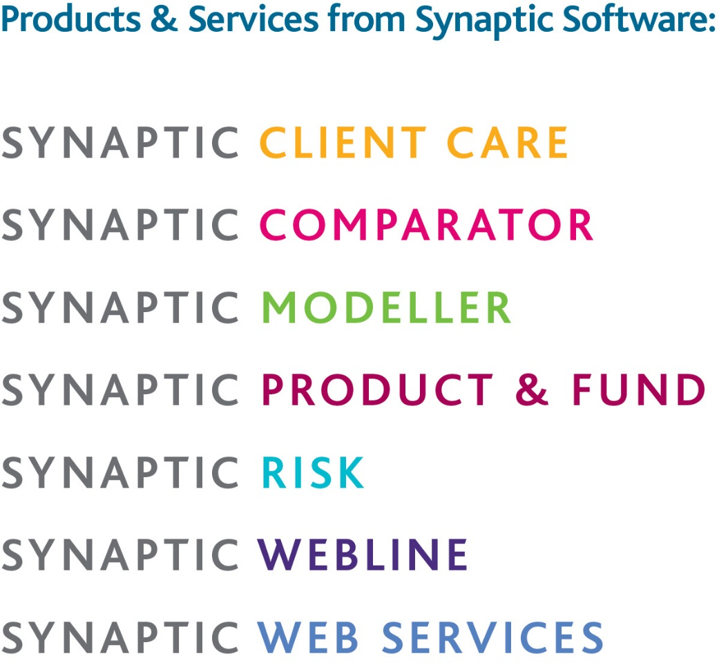
This document is the property of Synaptic Software Limited and the information contained herein is confidential. This document, either in whole or in part, must not be reproduced or disclosed to others or used for purposes other than that for what it has been supplied, without prior permission from Synaptic Software Limited. December 2016 v0.1

